Report of QuarkNet Activities at UIC and CSU during 2025-2026

The QuarkNet Program at the University of Illinois at Chicago and Chicago State provides mentoring, organization, and collaborative structure to students and teachers at six Chicagoland high schools that host cosmic ray detectors. UIC-CSU has provided detectors so that schools can perform physics experiments based on the detection of cosmic ray muons.

Part of the QuarkNet high school group consisting of five teachers and more than fifteen students have focused on cosmic ray data originally taken in 2024. A large Forbush decrease in the muon flux was observed in our detectors due to a Coronal Mass Ejection (CME) event in May 2024. It became the theme for our three-day summer workshop July 2024. Data selection, determination of goals, and preliminary analysis was accomplished during that workshop. Final analysis of detectors at ten sites was completed in several half-day meetings in the Fall and initial results were presented at AAPT, January 2025. During summer of 2025 students identified a journal in which to publish the CME measurement (Journal of Undergraduate Research in Physics and Astronomy), completed further analysis, and submitted the paper entitled “A CME paper The Relationship Between Coronal Mass Ejection Intensity and Cosmic Ray Flux to JURPA¹“ in August 2025. JURPA responded in June 2026 and responses to reviewers’ comments have been submitted.

This year’s summer workshop was held at Dominican University June 8-10, 2026, hosted by Professor Sagerer, co-PI of the NAUM project. The workshop was attended by seven students from three schools, five teachers, QuarkNet staff, mentor, and Fermilab QuarkNet computing expert. The goal was to obtain muon rate measurements at several zenith angles and to directly compare rates from the NAUM pyramid tracker and a QuarkNet CRMD. The CRMD was attached to the rotating NAUM detector frame. First, students completed several basic measurements with CRMDs; then mounted one CRMD onto the tracker. Edit Peronja and Mark (both at Fermilab QuarkNet) had developed a minimal analysis of tracker data that allowed students to measure muon rates and also to make aperture cuts on the tracker data so that it could match the acceptance of the CRMD. Students were shocked that the two detectors agreed to within a few percent. They wrote a poster to guide and then summarize their work. A guest Northwestern graduate student Shafaq Elahi gave a talk on dark matter searches. Mark described the Pyramid project and Edit presented a talk on the analysis tools that provide feedback of the performance of the tracker.

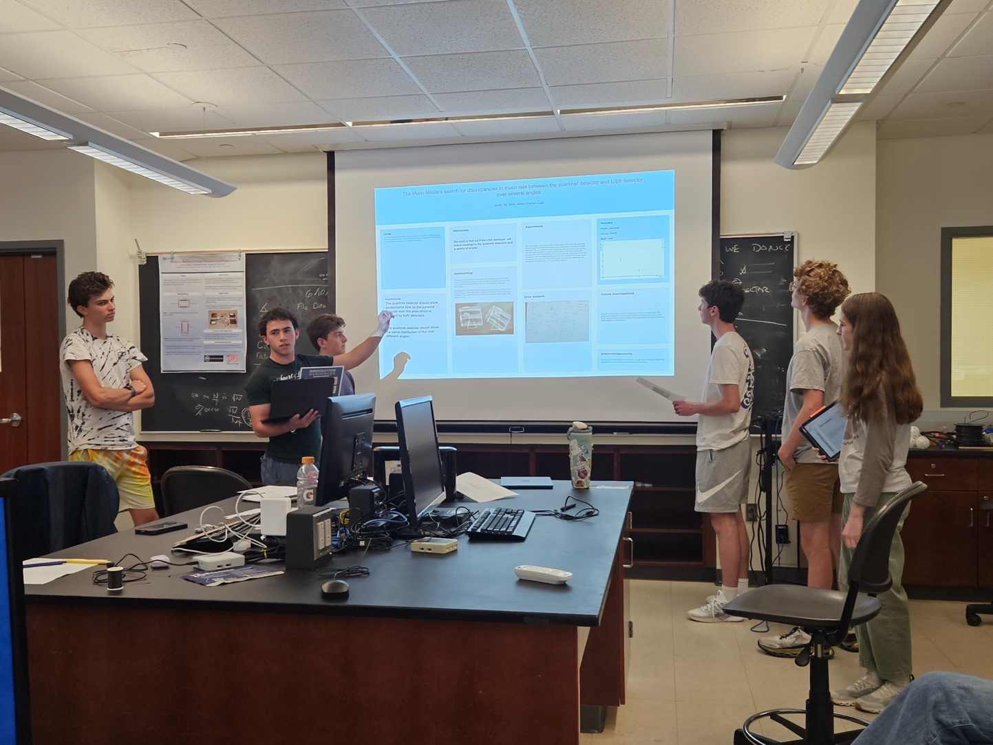
Students presenting their poster on simultaneous measurements of the dependence of muon rate on zenith angle.

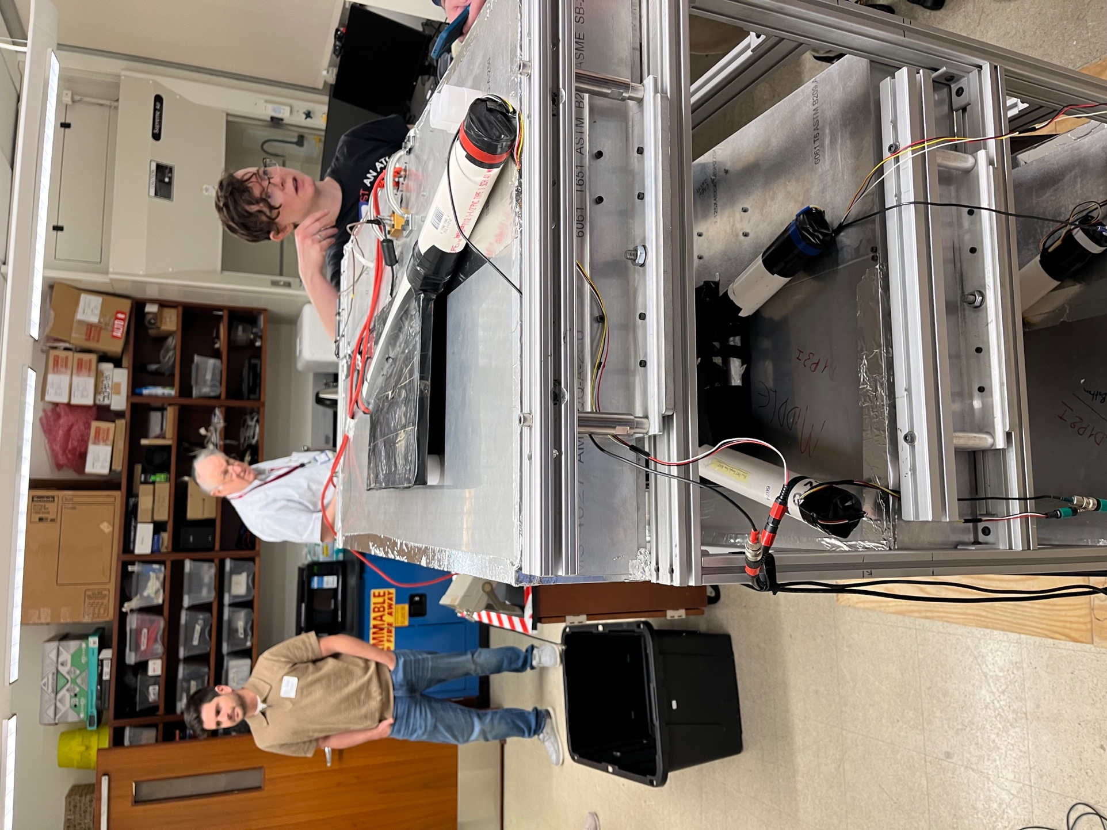
Teachers inspecting cabling of the CRMD.
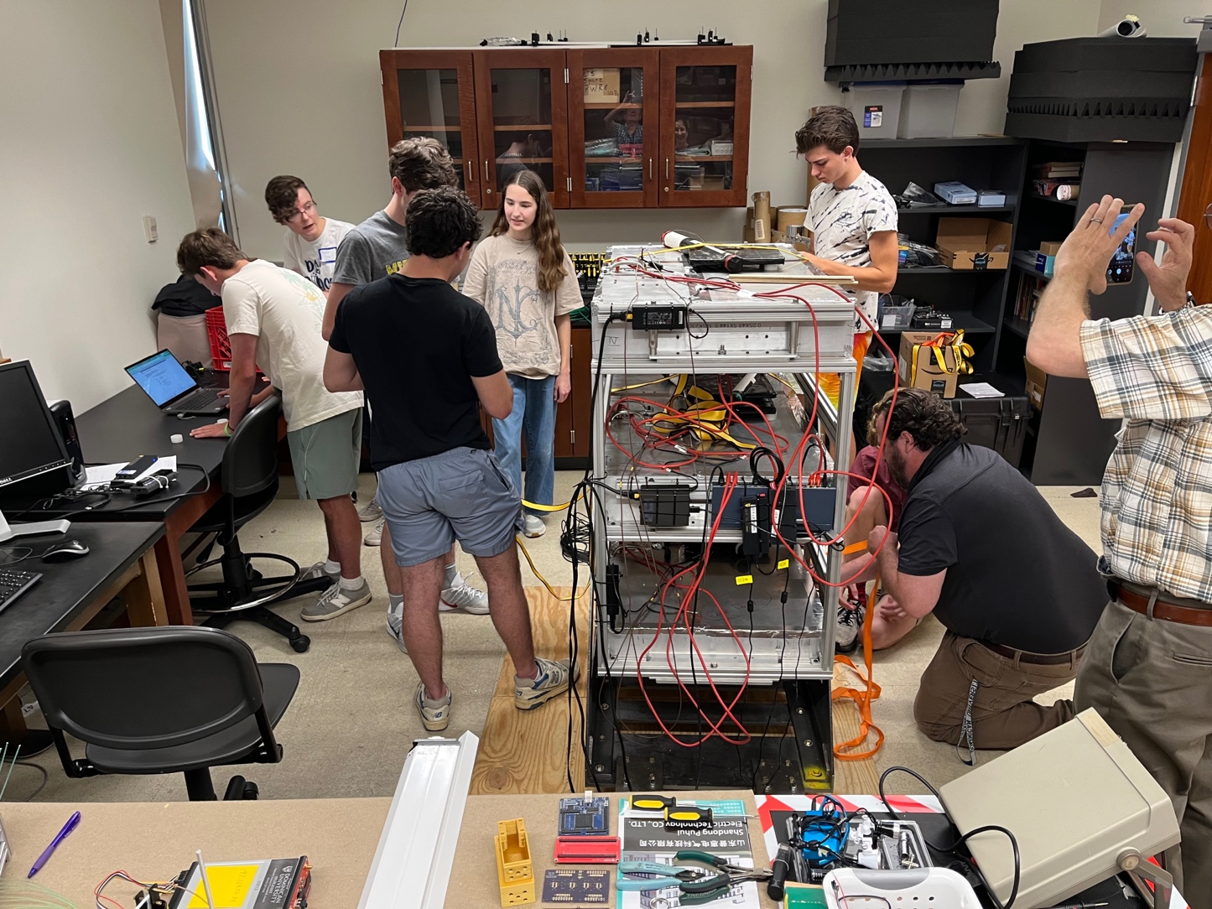
QuarkNet 2026 summer workshop participants setting up cosmic ray detectors.

In addition to the projects above Nate Unterman developed instructions for completing muon rate corrections due to pressure using e-Lab tools and Marybeth Senser has organized a US-Japan high school collaboration.

During the academy year six students at DGS studied muon rates as a function of solar activity spanning many years of historical flux data and compared it to flux data recorded by a balloon borne detector over the same period, indicating significant qualitative and quantitative differences in stratospheric radiation vs surface muon flux. Their poster on the Impact of the Solar Cycle on Cosmic Ray Muons in shown below. Three students used data from the CRMD and the school's solar panels to study the correlation between solar flux and muon flux. Their poster Solar Energy vs Muon Flux is shown below.

A group of DGS students also performed a study of how lead plates affect flux and presented their results at International Cosmic Day in November 2025. Three DGS students participated in worldwide data day, also November 2025.

Students compare historical muon flux at the surface to results from balloon flights during the latest solar cycle.

Students compare muon flux with solar flux measures at their school.

Pyramid

Edmundo Garcia is principal investigator of the NAUM experiment that has built a scintillation tracker to image the interior of the pyramid at Chichen Itza, Mexico. Sample data is hosted on QuarkNet’s e-Lab; available to all users. Joe Sagerer, at Dominican University, is also a NAUM principal investigator. He uses a second detector located at DU to optimize the tracker readout. Joe hosted our QuarkNet group this summer and facilitated the joint tracker-CRMD experiment.

The first detector was installed in the pyramid at the end of January 2026. Mark worked with Edit developing the website, analysis to monitor performance, and studying and correcting for hardware errors generated in the readout system. Edit monitors data every day.

We anticipate that high schools in the UIC-CSU Center will participate in the calibration process during the next academic year and possibly, in the future, use data to improve the sensitivity of their moon shadow measurement.

Mark Adams  UIC Professor Emeritus of Physics | Edmundo Garcia- Solis  CSU Physics Professor  Associate Provost of Research and Grant Administration

References:
- The Relationship Between Coronal Mass Ejection Intensity and Cosmic Ray Flux, Kristian Qirko, Rex Paster, Evangeline Selking, Zoya Siddiqui, Sydney Stapleton, Maya Zacks, Marybeth Senser, Nathan A. Unterman, Mark R Adams, to be published in the Journal of Undergraduate Research in Physics and Astronomy.

